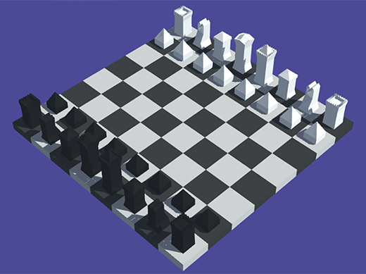

## How to use

1. Use prefabs from package

2. Or use textured models and vertex colored models

3. You can change texture for textured models

4. Enjoy